Attachment 2
Response to selection criteria form

To assist you in completing this form…

Tell us about any relevant work experience, qualifications, skills and/or knowledge you have that are relevant to this position

The most recent the information, the better. Try to provide detail about duties performed most recently and avoid including information not relevant to this position you are applying for

Remember to tell us about both direct experience / skills (i.e.: from the same types of work) as well as experience and experience you may have gained from other places

It is good to give specific examples of what you know, where you learnt it and to give concrete examples of how you have applied it in the past (e.g.: where and how you’ve used these skills before)

Try to give different examples to each criteria that show how you meet them rather than repeating the same information/examples

Your Name:
Job Number: | 005HCS

Essential:

Click or tap here to enter text.

Click or tap here to enter text.

Click or tap here to enter text.

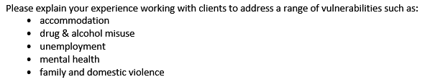
Click or tap here to enter text.

Click or tap here to enter text.

Click or tap here to enter text.

Click or tap here to enter text.

Click or tap here to enter text.

Click or tap here to enter text.

Please list the computer programs you feel competent with
☐ Microsoft Word
☐ Microsoft Excel
☐ Email
☐ Internet
☐ Client management system or database

Choose an item from the list below

Choose an item from the list below

Desirable:
Please note: The questions below are optional to answer

Click or tap here to enter text.

Choose an item from the list below

Click or tap here to enter text.

Click or tap here to enter text.

Click or tap here to enter text.
https://www.fams.asn.au/about-us/fams-principles

